How Do You Make Paper from Trees? Quiz/Answer Key

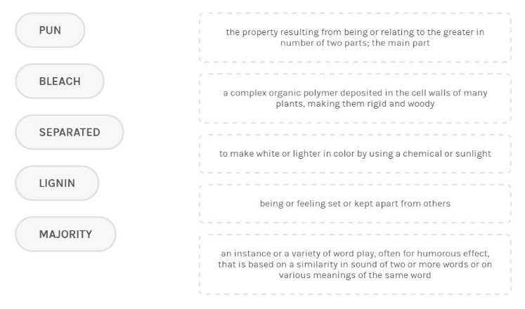
Match To Definition Order: majority, lignin, bleach, separated, pun
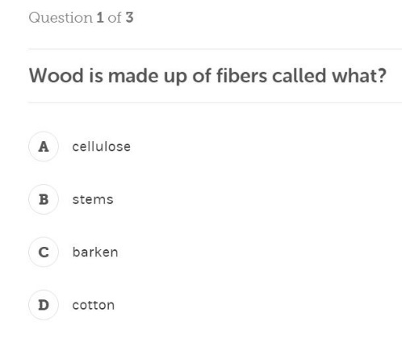
Correct: A, Cellulose
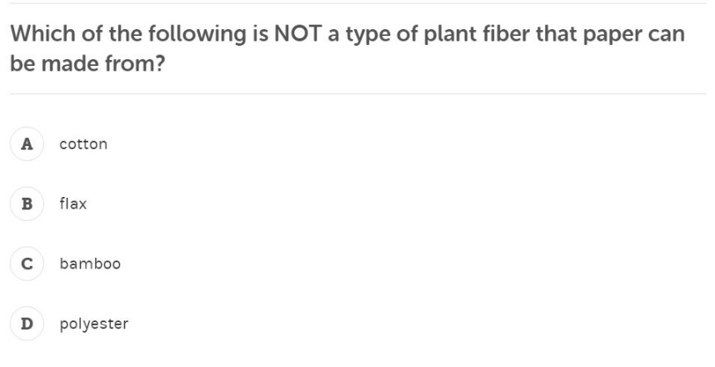
Correct: D, Polyester
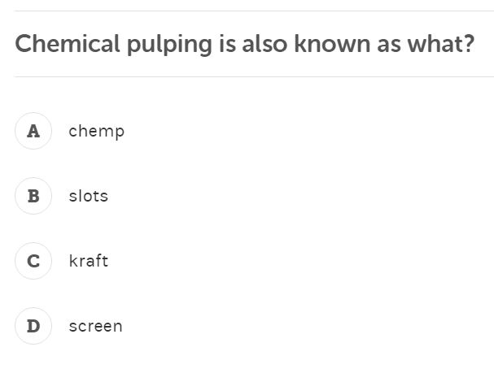
Correct: C, Kraft

